**Report out: AI playground**

Last meetup we had an AI playground to see what we can do to create the Ladybug Front-end using AI.

Willem, Joris, Lucy and I tried out different AI tools to create the landing page and the results page of the Ladybug.

[Click here for more information about the idea of automatic usability testing tool the Ladybug.](https://github.com/Ksnoyl/Ladybug)

This is a report out on the tools we tested and the results.

This is what Kimberly made before the meetup using ChatGPT only: <https://youtu.be/bEqx1Tls-jQ>

It took an hour or more and the results were nice, but adding visuals to the results page, such as graphs and accordions did not work with ChatGPT. “It did help me step by step to use GitHub Codespaces and run my code in the cloud.”

These are the pros and cons of using ChatGPT to create user interfaces:

+ It is possible to generate code with prompts with ChatGPT

+ ChatGPT helps you to run the code in GitHub Codespaces

+ It can add styling, but you have to ask for it

* You must run the code somewhere else to see it
* The code did not work for Images, charts and accordions
* You must ask to add styling, it does NOT add styling by itself

After this experience, which I was already quite surprised with using it for the first time, the AI Playground blew my mind with what is possible using other AI tools!

Kimberly

Below is a description of the AI-assisted design tools we tried and our experiences. We did three rounds of 10 minutes with three people, because we learned in the first round that you can create an entire page within 10 minutes!

[UIzard](https://uizard.io/)

converts text prompts and hand-drawn sketches into mockups.

The prompt Willem used was “a textbox where you can input a URL with 10 buttons below”

Unfortunately, something different came out, although it looks quite good.

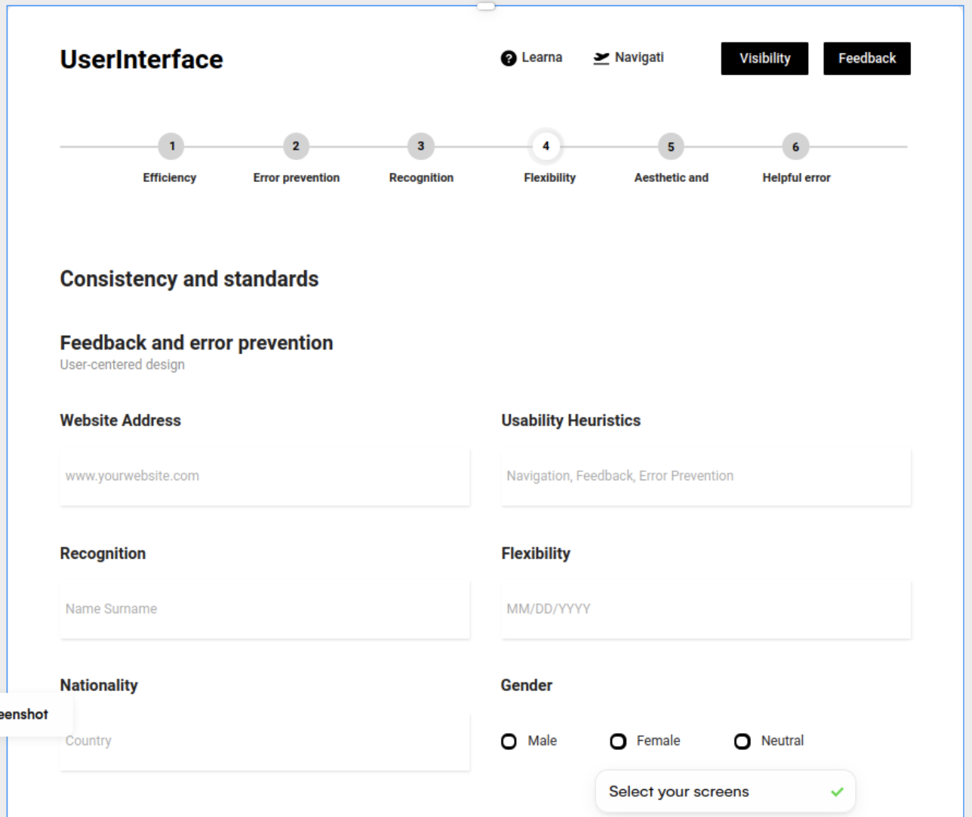

Figuur 1 User interface for the Ladybugs landingpage made with UIZard

These are the pros and cons of using UIZard to create user interfaces:

+ UIZard automatically adds a header and stepper

+ looks quite good/professional

* Registration took a long time. They want to know a lot of information.
* The results did not match the prompt given
* No colors

[Builder.io](https://www.builder.io/)

transforms Figma designs into optimized web and mobile experiences with half the effort

Kimberly tried [Builder.io](http://Builder.io) but was not able to get results in 10 mintutes. “Later on I got it working (while working on this report out) and it gives you different styles to choose from. This is different from the other tools.”

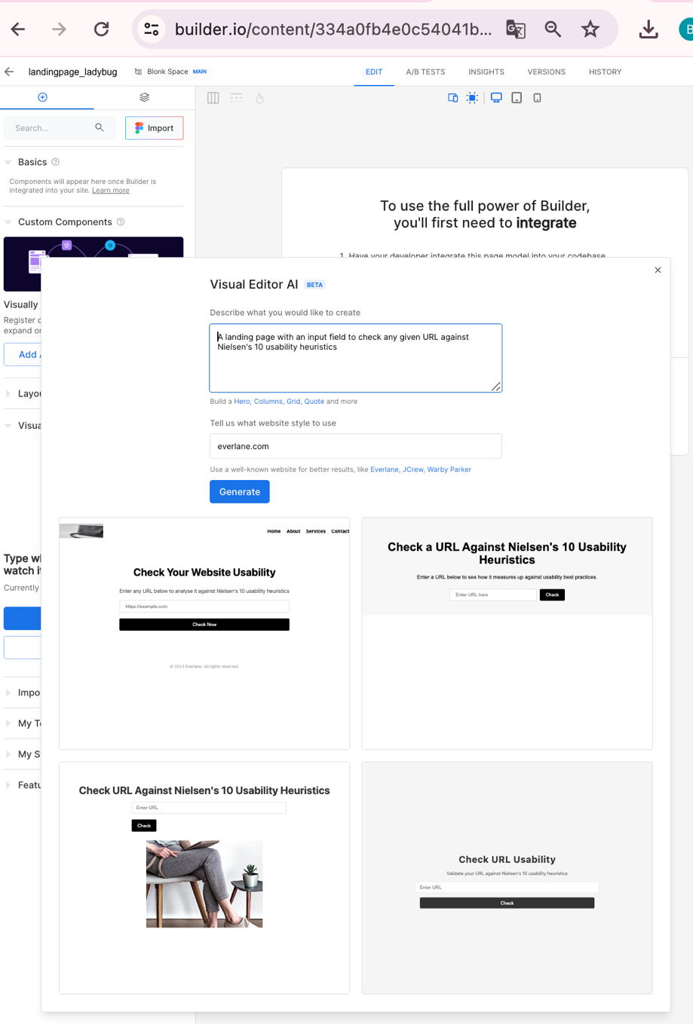

Unfortunately, when I chose one of the four designs I could not find my chosen design. We can conclude that it takes some time to learn to use this tool, but it looks like it has a lot of options like A/B tests and versions. “Also, when I tried to generate the 4 designs again, with the same theme, I got a different style. This makes me wonder how we will make sure that the Ladybug gives the same results when checken a website multiple times…”.

[Canonic](https://canonic.dev/)

offers the ability to create AI-generated full-stack applications without requiring any code knowledge at all.

This did not work as expected. It was not clear how to add a prompt.

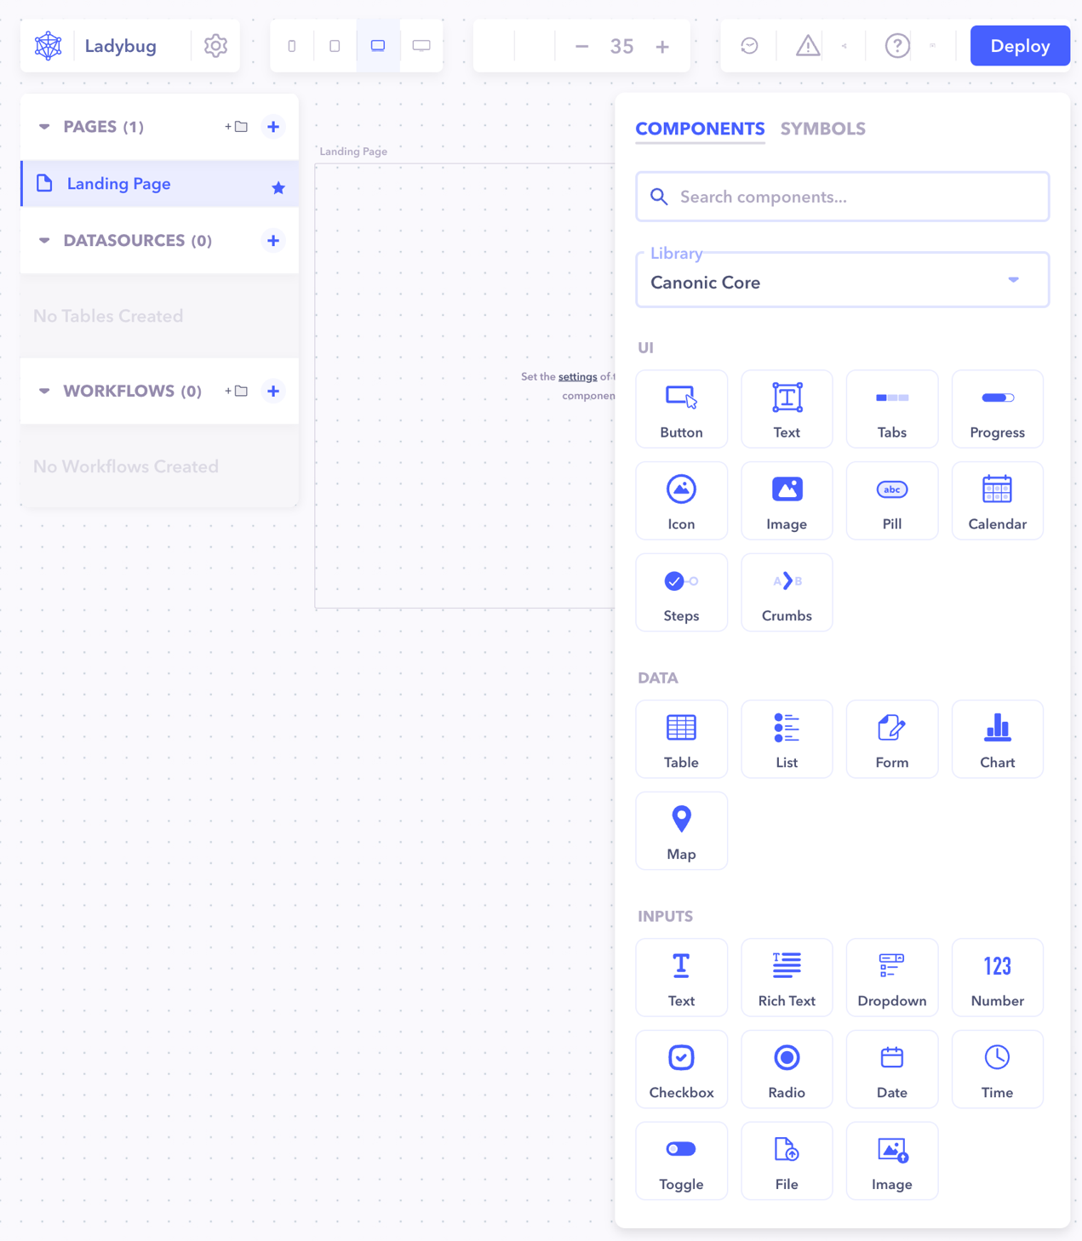

[v0 by Vercel](https://v0.dev/)

Can turn text prompts into simple coded prototypes

We were quite surprised with the results of V0 by Vercel! Joris used this tool, because he already was familiar with another tool by Vercel (Nextjs). He used the prompt: “Make a landing page for testing the heuristic of nielsen. A search bar where you can put in the website url you want to test on”. For each prompt you get 3 different designs to choose from. In Figure 2 you can see the results of one of the three.

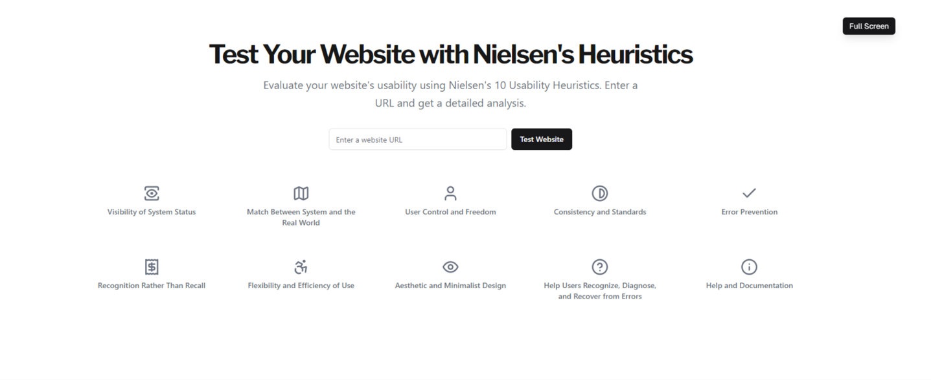

Figuur 2 User Interface for the Ladybug landing page created with V0 by Vercel

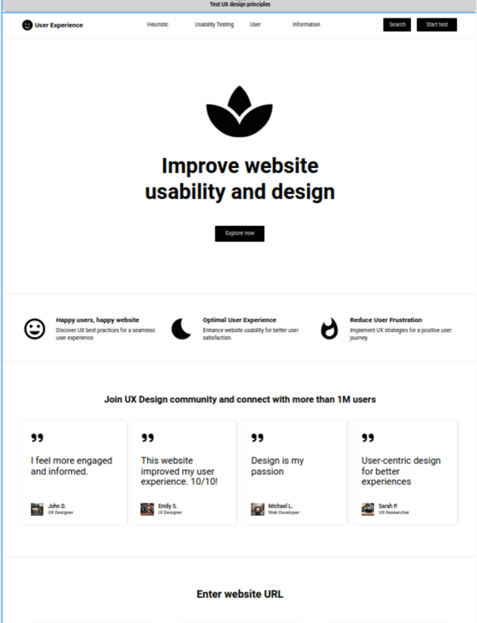

Figuur 3 Another version of the Ladybug landing page created with V0 by Vercel

In the next round Joris experimented further with Vercel and got quite good results! The promt he used was: “Make an all results page of a tool that test a website on the heuristics of nielson. Do check mark for passes and crosses for fails. Also add a sort of chart that summarizes it. Use icons to show which heuristic it is. Also give tips on how to fix it if it is not passed. Check on all heuristics say on top which website is tested on and maybe add screenshots”

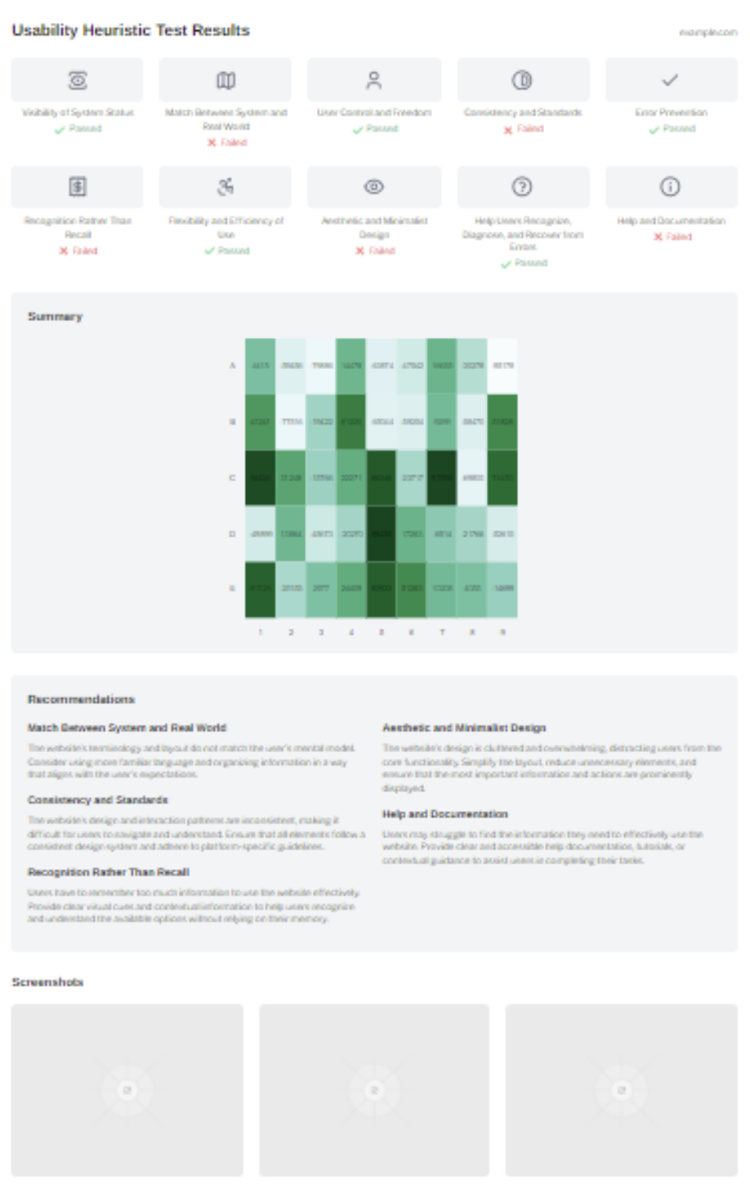

Figuur 4 Results page made with V0 by Vercel

Figure 2 looks quite good and gives inspiration on how to visualize the results.

Another prompt:

“Make an all results page of a tool that test a website on the heuristics of nielson. Do check mark for passes and crosses for fails. Also add a sort of chart that summarizes it. Use icons to show which heuristic it is. Also give tips on how to fix it if it is not passed”

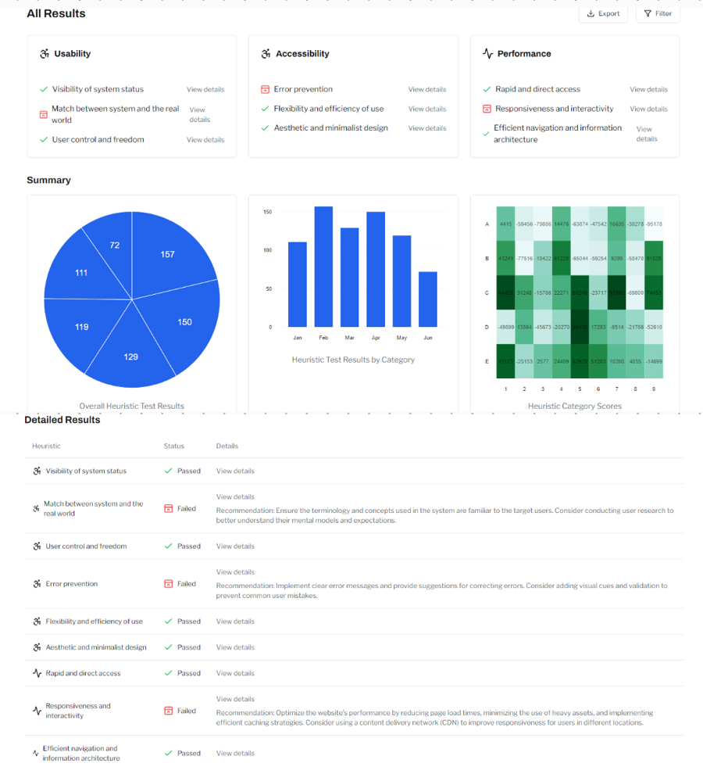

[Create](https://zapier.com/blog/best-ai-app-builder/#create-xyz)

for building an app with a single detailed prompt.

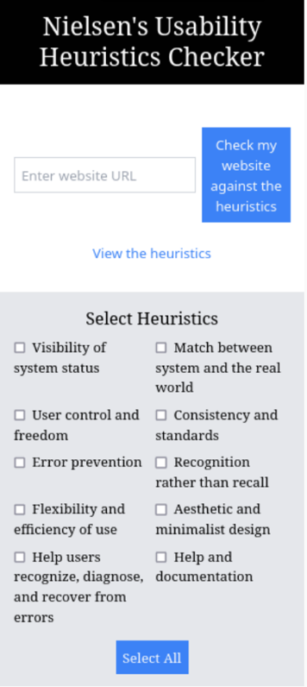

Prompt used by Lucy for the results page: “Generate a website results page measuring a site against Nielsen's 10 heuristics, with numbers out of 10. Include a graph to show strong and weak areas. Make each of the 10 heuristics clickable, so they expand to explain what is good/bad and offer tips on improvement. Add a ladybug logo top left and "Ladybugs Heuristics Checker" centre in the header. Add creative styling.”

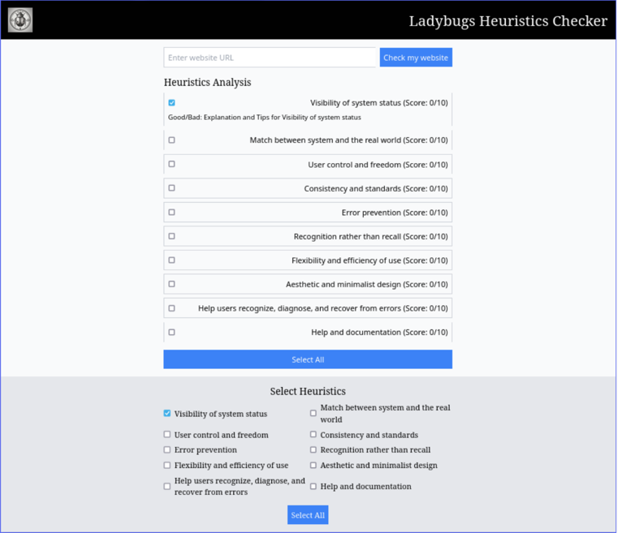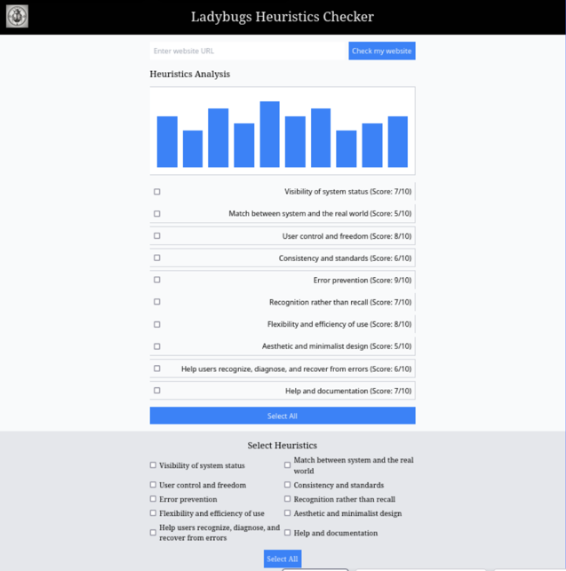

Prompt: “Generate a mobile app results page measuring a mobile site against Nielsen's 10 heuristics, with scores out of 10. Include a graph to show strong and weak areas. Make each of the 10 heuristics clickable, so they expand to explain what is good/bad and offer tips on improvement. Add a ladybug logo top left and "Ladybugs Heuristics Checker" centre in the header. Add creative styling.”

* It didn't understand mobile app?
* Suddenly has graphs
* Changed 'numbers' to 'score' and it understood better

Kimberly also used Create and got the following results:

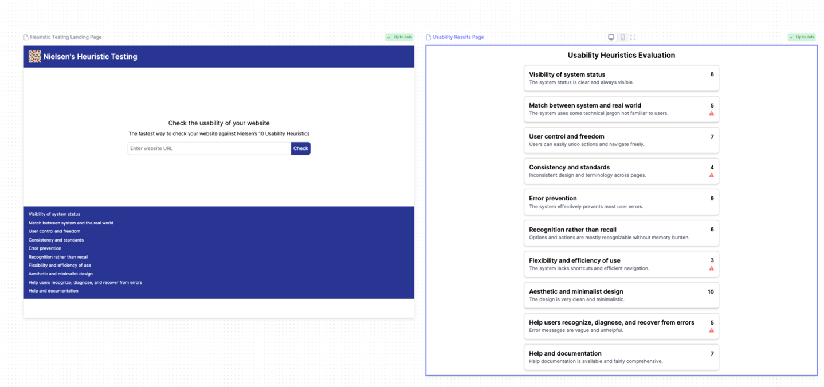

It looks quite good, but the footer changed. It recreated including all previous prompts, while the other tools add or change the design with each new prompt.

These are the pros and cons of using Create to create user interfaces:

+ Create is easy to use

+ Does exactly what I asked in the prompt

+ Clean, but not necessarily pretty page (don't like

all the checkboxes, could be done differently)

+ it looks like a prototyping tool, so you can make multiple pages next to each other

+/- Seemed to remember and copy everything from the last prompt, which I didn't want

* Didn't follow all my instructions exactly
* Too many checkboxes, when this can be done in a more attractive way
* Asked it to use creative styling and nothing changed

On trying to make a mobile app version, kept it identical and squashed everything together

## [Pico](https://zapier.com/blog/best-ai-app-builder/#pico)

for building only with prompts

These are the results of Willem and Kimberly using Pico

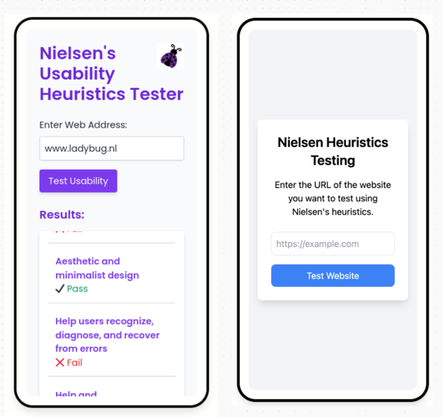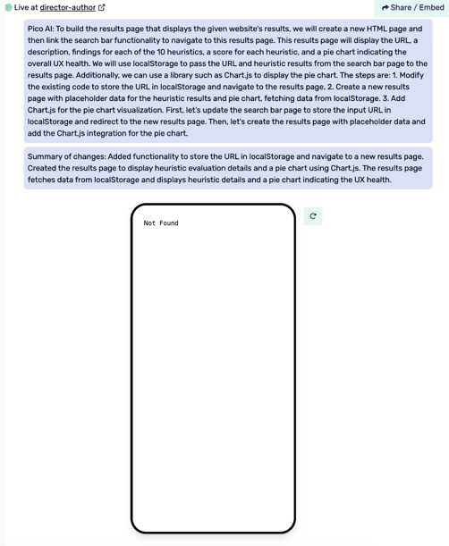

These are the pros and cons of using Pico to create user interfaces:

+ I click login with google

+ 3 opties: meta, Basic or chatbot

+ Simple design, exactly what the prompt is

+ it explains what it does and why

* Mobile only design
* Unfortunately, it was not possible to make it interactive and show the results page after clicking on the button even though it created a page. I never saw it.

## [AgentGPT](https://www.linkedin.com/company/agentgpt/)

autonomously does any task you give it:

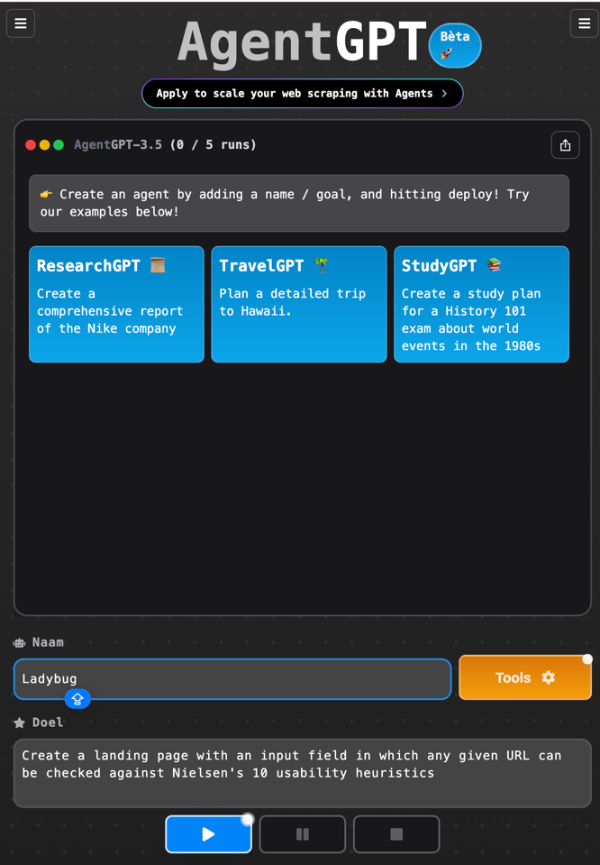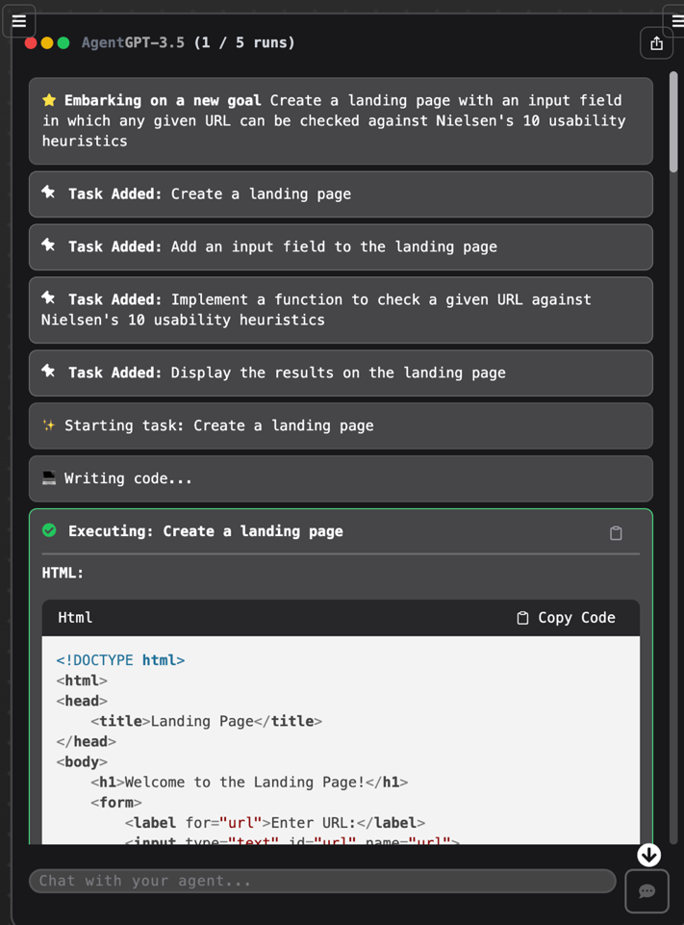

* English and Dutch used on the first page. Not sure if it is a Dutch tool or that it know where I am and automatically translated part of the page to my language.
* After prompting you have to login
* You get code but have to run the code somewhere else to see it. In the other tools you get the code and also how it looks like.

Not really what I’m looking for. I have to find out a way to run the code so I can see what AgentGPT made.

Willem also used [Retool](https://retool.com/), which was not on our list, but he know the tool from….

The results were not very good. We would not recommend this tool.

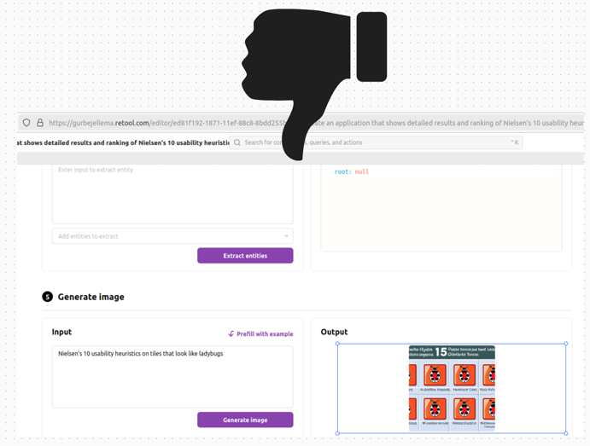

## Summary:

We learned that there are different AI tools for different purposes. To create a Front-end of an application, rather than using ChatGPT or AgentGPT our favorite tools are V0 by Vercel and [Create.xyz](http://Create.xyz). For mobile apps, instead of using [Create.xyz](http://Create.xyz)., use Pico!

These tools are intuitive to use, easy to log in (with Google, which may be a con for some people). They give you code and immediately you can also see what that code looks like as a user of the website.

For ChatGPT and AgentGPT you only get the code, and you need another tool to make it visible. These tools might be handy for developers, but not for people who are not so good with code.

We learned that prompting is very important: you must know what to ask and be clear in your prompts.